**Assignment -4**

Digital Marketing

|  |  |
| --- | --- |
| Student Name | Angel P |
| Student Roll Number | 20URCS004 |
| NM ID | A73DA3A38A9850BBE054E48B3B0E06EB |
| College Name | AAA College of Engineering and Technology |

**QUESTION:**

**Create email newsletter design using MailChimp or Canva tool.**

**EMAIL NEWSLETTER USING CANVA:**

**Newsletter link:** <https://www.canva.com/design/DAFtMpGiqRk/JQEbBQ8yzXpdsB2grteahg/edit?utm_content=DAFtMpGiqRk&utm_campaign=designshare&utm_medium=link2&utm_source=sharebutton>

**Newsletter Title: Rose Buds – Baby Shop**

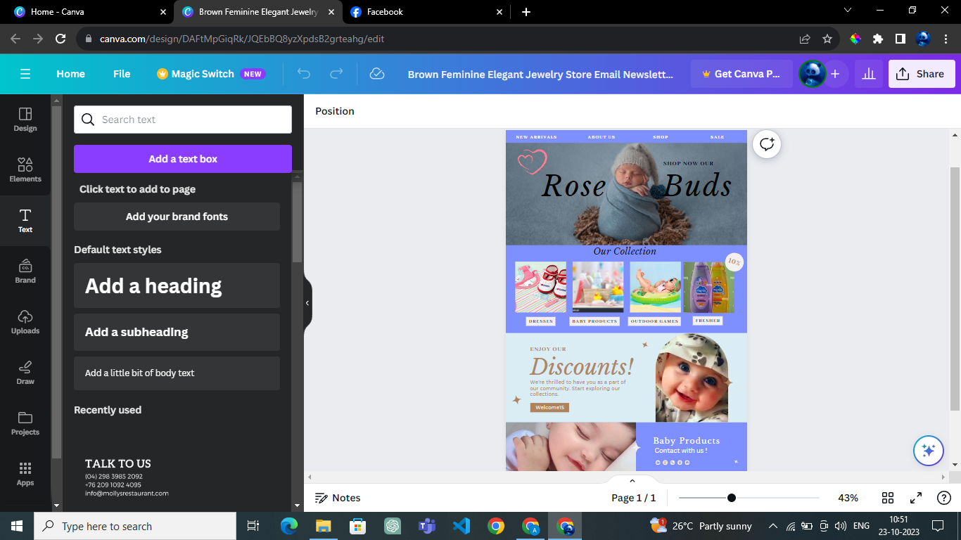

**Email Newsletter:**

